**WIND MODES TOWER FANS:**

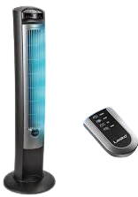

**Price: 9,000.00**

The Wind Modes Tower Fan is a versatile and innovative cooling solution, offering multiple wind modes to simulate natural breezes. With its advanced technology, this fan replicates the gentle rustle of a summer breeze, the soothing calm of a sea breeze, or the invigorating rush of a mountain wind. Its sleek tower design, adjustable speed settings, and quiet operation make it perfect for homes, offices, and bedrooms, providing a refreshing and immersive cooling experience.

**Key features of wind modes tower fans include:**

* **Multiple Wind Modes**: Options like normal, natural, or sleep modes.
* **Adjustable Speed**: Customizable airflow intensity.
* **Oscillation**: Even air distribution.
* **Quiet Operation**: Minimal noise for comfort.
* **Energy Efficient**: Low power consumption.